# **Chapter 20 – Measuring the GDP and Economic Growth**

**Gross Domestic Product (GDP)**

GDP or gross domestic product is the market value of all finals goods and services produced in a country in a given time period.

The definition has four parts:

*Market Value*: Goods and services being valued at their market prices

*Final goods and services:* A final good is a good purchased by its final user.

NOTE: We have to be careful to not double count the intermediate value of goods and services.

*Produced within a country:* All the goods counted in a GDP are domestic produce.

*In a given time period:* GDP is measured for quantities over a certain period of time. Like a year or a quarter of the year.

**GDP and the circular Flow of Expenditure and Income**

GDP measures the value of production, which also equals total expenditure on final goods and total income.

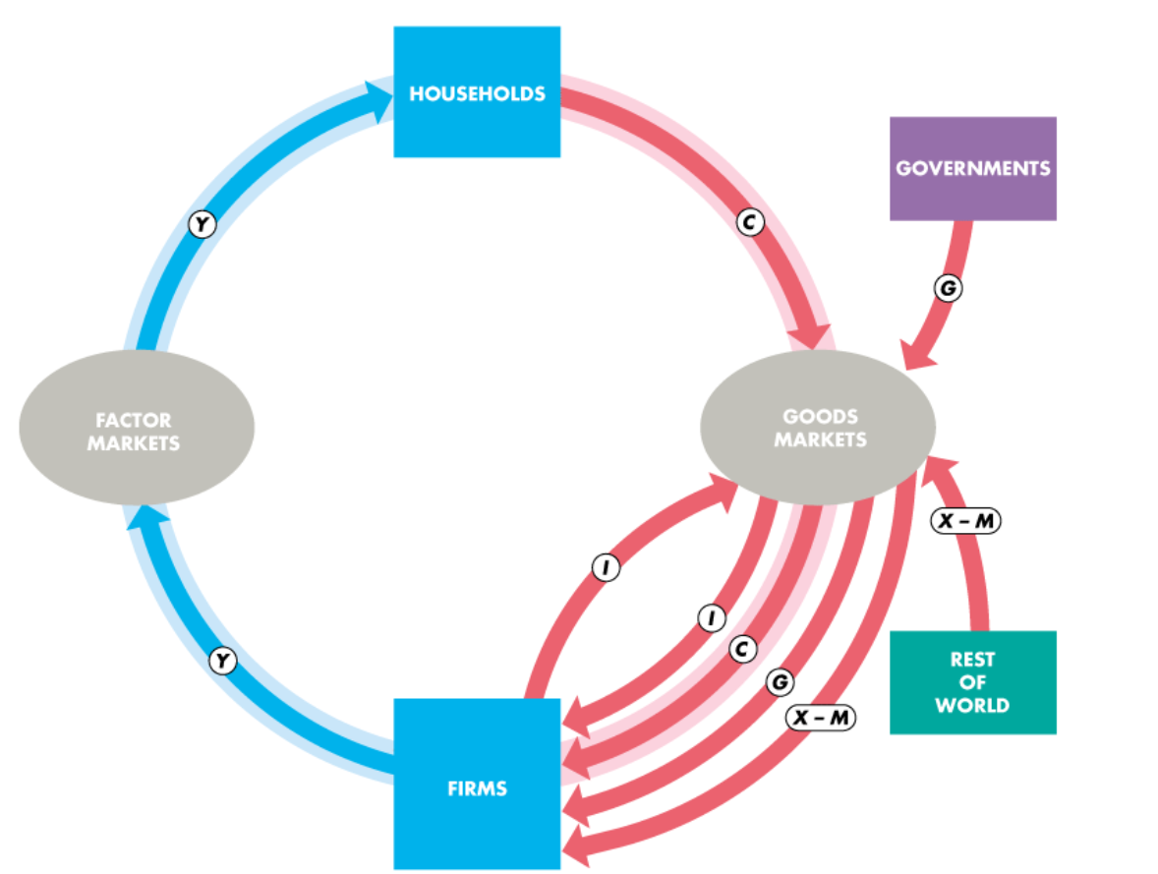

Figure 1 Circular Flow of Expenditure and Income

**Households and Firms**

Households sell, and firms buy the services of labour, capital, and land in **factor of markets**.

Y corresponds to total income paid by Firms to households for the services

*Total Income(Y) = Rent + Wages + Interest + Profit*

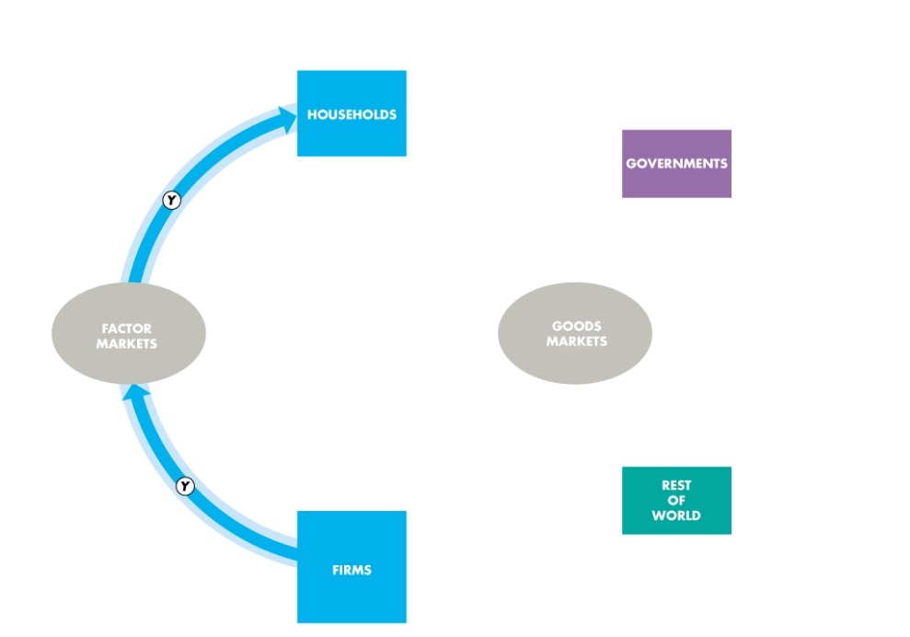

Figure 2 Flow of Income in Factor of Markets

Firms sells, and households buy consumer goods and services in the **goods market.**

*Consumer Expenditure (C):* Total payment for goods and services

The purchase of new plant, equipment, and buildings and the additions to inventories are **investment,** denoted by I, in red flow

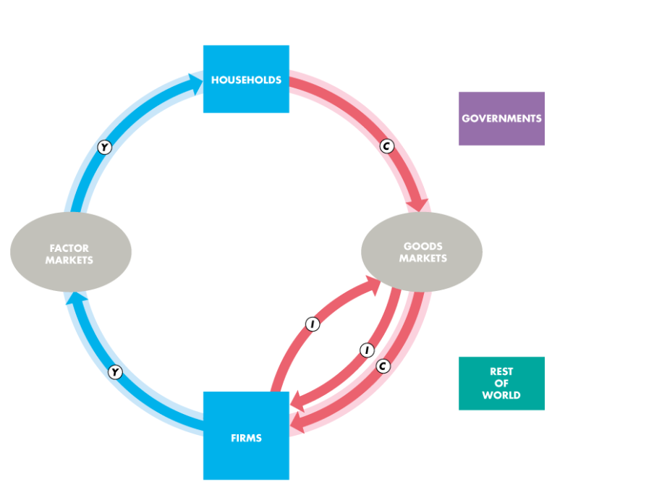

Figure 3 Flow of Expenditure in Goods Market

**Governments**

Governments buy goods and services from firms and their expenditure on goods and services is called **government expenditure,** denoted by G, in the red flow.

The government gets money from taxes we pay. They also provide subsidies, and pay financial transfers to households, such as unemployment benefits. These are not a part of circular flow of income and expenditure.

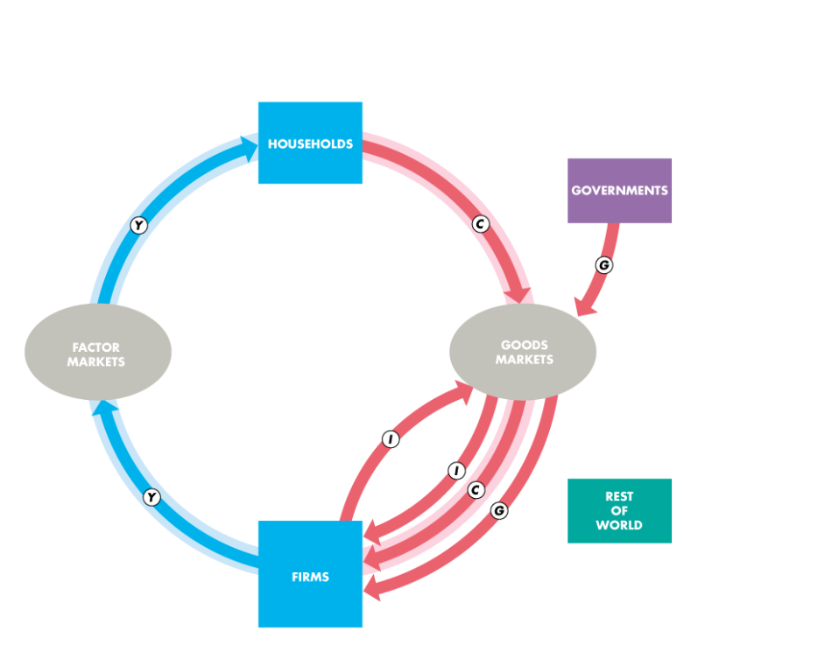

Figure 4 Government Expenditure in the Flow

**Rest of the World**

Firms in all over the world buy some goods and services from other countries as well as sell some goods and services. These are *Imports* and *Exports* respectively.

The value of imports(M) subtracted from the value of exports (X) gives us the income from the net exports.

*Net Exports:* X – M

This expression of net exports is positive when we export more than import and is negative when we import more than export.

The net flow of rest of the world is shown by red flow

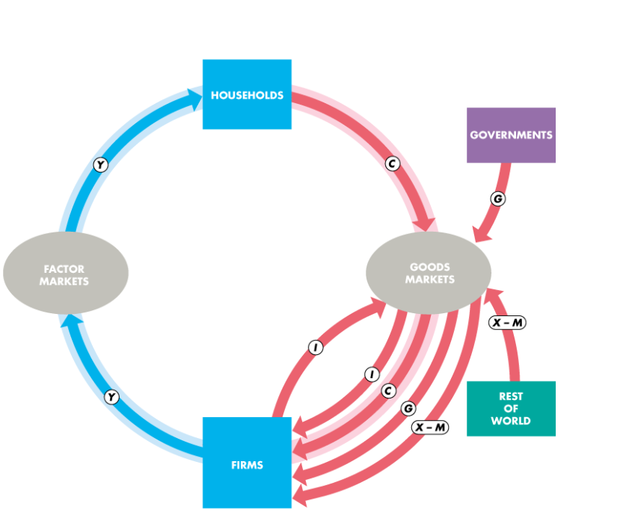

Figure 5 Flow of Net Exports

The sum of the red flow equals the sum of the blue flow.

*Y = C + I + G + X - M*

*GDP Equals the Expenditure and Income, which means that*

GDP = C + I + G + X – M

**Why is Gross domestic product “Gross”?**

Gross means before the deduction of depreciation of capital. The opposite of “gross” is “net”.

**Depreciation** is the decrease in the value of a firms’ capital that results from wear and tear.

**Gross investment** is the total amount spent on purchases of new capital and on replacing depreciated capital.

**Net investments** is the increase in the value of the firms’ capital.

*Net Investment = Gross Investment – Depreciation*

**Measuring Canada’s GDP**

The Bureau of Economic Analysis uses two approaches to measure the GDP:

*The expenditure approach:* Calculate the red flow of the consumer flow of expenditure and income.

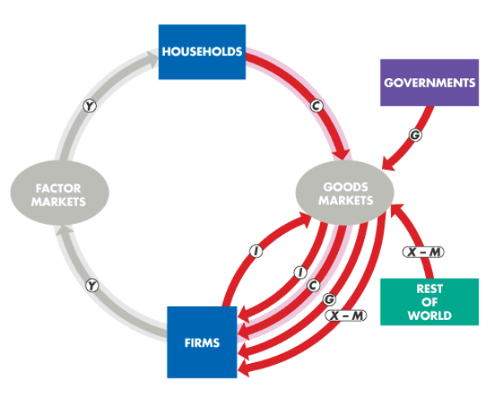

Figure 6 Expenditure Approach to GDP

*The income approach:*  Calculates the blue flow of the consumer flow of expenditure and income. The Income is though separated into two different factors,

1. Wages, Salaries, and other labour income
2. Other factor incomes

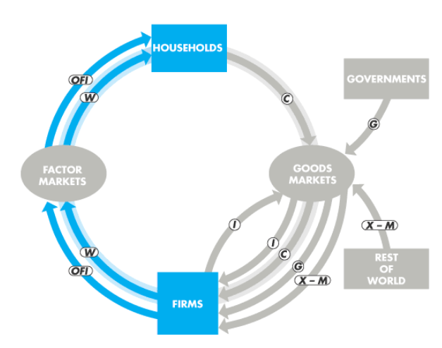

Figure 7 Income Approach to GDP

In the income approach to GDP we have to make two adjustments that is *indirect taxes, such as GST o HST, less subsidies* and *Depreciation*

**Nominal GDP and Real GDP**

*Real GDP:* It is the value of final goods and services produced in a given year when valued at the prices of a reference base year

*Nominal GDP:* It is the value of goods and services produced a given year valued at the prices that prevailed in that same year